

**Karnel Travel**

|  |  |  |
| --- | --- | --- |
| **Supervisor:** | *Le Tuan Xuyen* | |
| **Semester:** | *III* | |
| **Batch No:** | *T1.2201.E0* | |
| **Group No:** | *2* | |
| **Order:** | **Full name** | **Roll No.** |
| *1.* | Nguyễn Xuân Thành | Student1345187 |
| *2.* | *Huỳnh Nhật Trung* | *Student1345349* |
| *3.* | *Phạm Gia Hưng* | *Student1345178* |
| *4.* | *Nguyễn Minh Hoàng* | *Student1345179* |
| *5.* | *Dương Khai Cường* | *Student1341576* |

***Month****: 5* ***Year****: 2023*



This is to certify that

|  |  |  |
| --- | --- | --- |
| **Mr.** | **Nguyễn Xuân Thành** |  |
| **Mr.** | **Phạm Gia Hưng** |  |
| **Mr.** | **Nguyễn Minh Hoàng** |  |
| **Mr.** | **Huỳnh Nhật Trung** |  |
| **Mr.** | **Dương Khai Cường** |  |

Have successfully Designed & Developed

|  |  |  |
| --- | --- | --- |
|  |  |  |
| **Karnel Travel** | | |

Submitted by:

|  |
| --- |
| **Mr. Le Tuan Xuyen** |

Date Of Issue:

|  |  |
| --- | --- |
|  |  |

Authorized Signature:

|  |  |
| --- | --- |
|  |  |
| **Content** | | | |

Content

Acknowledge

Synposis

Review1

Tasksheet

|  |
| --- |
| **Acknowledge** |

As we understand that the Project is a step-by- step learning environment that closely simulates the class-room and Lab based learning environment into actual implementation. It is a project implementation at your fingertips!! An electronic, live juncture on the machine that allows you.

* Practice step by step i.e., laddered approach.
* Build a larger more robust application.
* Usage of certain utilities in applications designed by user.
* Single program to unified code leading to a complete application.
* Learn implementation of concepts in a phased manner.
* Enhance skills and add value.
* Work on real life projects.
* Give real life scenario, help to create applications more complicated and useful.
* Mentoring through email support.

We would like to send a great thank to our professor, Mr Le Tuan Xuyen and others student for the adorable supports during the time in project.

Beside several mistakes we had made in the project, we hope to have more opportunities to widen our knowledge in web developing world. We also thank you so much for your information and the “demo” project from India APTECH to help us get more reality experience in this project. Since we have gained more experience from this project, we will not stop learning anything as much as we can to be more successful in the future.

Best Regards,

Group 02.

|  |
| --- |
| **Synopsis** |

The Objective of this program we aim is to give a sample project to work on real life projects. These applications help us build a larger more robust application.

The objective is not to teach us front-end or back-end technology but to provide us with a real-life scenario and help us create basic applications using the tools.

Hence, we can revise the chapters before we start with the project.

This project is meant for students like us who have completed the module of Semester III, as well as special subjects those are .Net and ReactJS. These programs should be done in the Lab sessions with assistance of the faculty if required.

The website (in this project) is a world that brings everything about the potteries and crockeries into your experience.

It is very essential for us that will have a clear understanding of the subject. We think we should go through the project and solve the assignments as per requirements given.

**Review 01**

|  |
| --- |
| **Problem Definition** |

The development of Information Technology and Internet help users access information, communication, transaction, or booking a trip are so easily. With the rise of technology, booking online has become a way to carry out the business transactions faster, more convenient, reduce cost for maintenance and employees.

With the price increment of products with the technology development, we bring to the customer a competitive environment to get the product with lowest price. We have many trips, tours, hotels, and resorts with reasonable price.

Based on the need stated in the Project Overall, we design an application that will provide the key features and functionalities as the followings:

* Provide function for user register.
* Provide information of the tour to customers and members.
* Provide a booking function so customers and members can book the tours.
* The member can take their privacy through Member Control Panel (MCP)
* Receive comments from customers and members to improve service quality as well as product quality.
* An Admin Control Panel (ACP) that support about management system:
* Administrators the ability to add, update product information quickly and accurately.
* Administrators the ability to manage members and their feedback, comment or rating.
* Administrators the ability to manage orders.
* Administrators the ability report statistics.

|  |
| --- |
| **Customer Requirements Specifications** |

The Role of User and Admin:

1. **User**:

* Can register as a member and manage personal account.
* Can view and book a tour, hotels, restaurants, and resorts.
* Can view their old tour, hotels, restaurant, and resorts.
* Can view the list of tour, hotels, restaurant, and resort which they can book.
* Can leave comment on the tour, hotels, restaurants, and resorts that they booked.

1. **Administrator**:

* Can add / edit / delete tours, hotels, restaurants, and resorts.
* Can view customer’s information or deactivate an account.
* Can view all orders and approve orders.
* Can view report statistics.

**User:**

**Input:**

* Member registration data.
* View tour’s data.
* View hotel’s data.
* View restaurant’s data.
* View resort’s data.
* Order selected tour.

**Process:**

* Search tours from database by beaches, monuments, hotels, restaurants, and resorts based on the location, price, quality, quantity, and availability.
* Process customer registration information.
* Process customer orders.

**Output:**

* Notification of successful registration / failure.
* tour information.
* Notification of successful booking a tour.

**Webmaster:**

**Input:**

* Administrator login data.
* Tours, hotels, restaurants, and resorts information to add / edit / delete.
* Member data to search / delete.
* Order data to search / approve.

**Process:**

* Add / edit / delete tours, hotels, restaurants, resorts.
* View information of all members.
* View all booking.
* Update booking status.

**Output:**

* Notification to add / edit / delete tours, hotels, restaurants, and resorts success / failure.
* Notification to change member account’s status.
* Notification to update booking’s status

**Hardware / software requirement**

1. Windows 7 (or higher if possible)
2. HTML5 / Css3 / JavaScript / .Net6 / ReactJS 0.1.0
3. Visual Studio 2022 / Visual Studio Code
4. SQL Server 2000 (or later)

Task Sheet Review 1

|  |  |  |  |  |  |  |  |
| --- | --- | --- | --- | --- | --- | --- | --- |
| **Project Ref. No.:**  **eP/Advertisement** **Portal Management** **System/01** | | **Project Title:** | **Activity Plan** **Prepared** **By:** | **Date of Preparation of Activity Plan:** | | | |
| **Sr.No.** | **Task** | **Actual Start** **Date** | **Actual** **Days** | **Team** **Mate** **Names** | **Status** |
| 1 | Acknowledge | Karnel Travel | All member | 19/05/2023 | 1 | KHAI CUONG | Completed |
| 2 | Problem Definition | 19/05/2023 | 1 | XUAN THANH, GIA HUNG | Completed |
| 3 | Customer Requirement Specifications | 19/05/2023 | 1 | MINH HOANG, NHAT TRUNG | Completed |

**Review 02**

|  |
| --- |
| **Data Flow Diagram** |

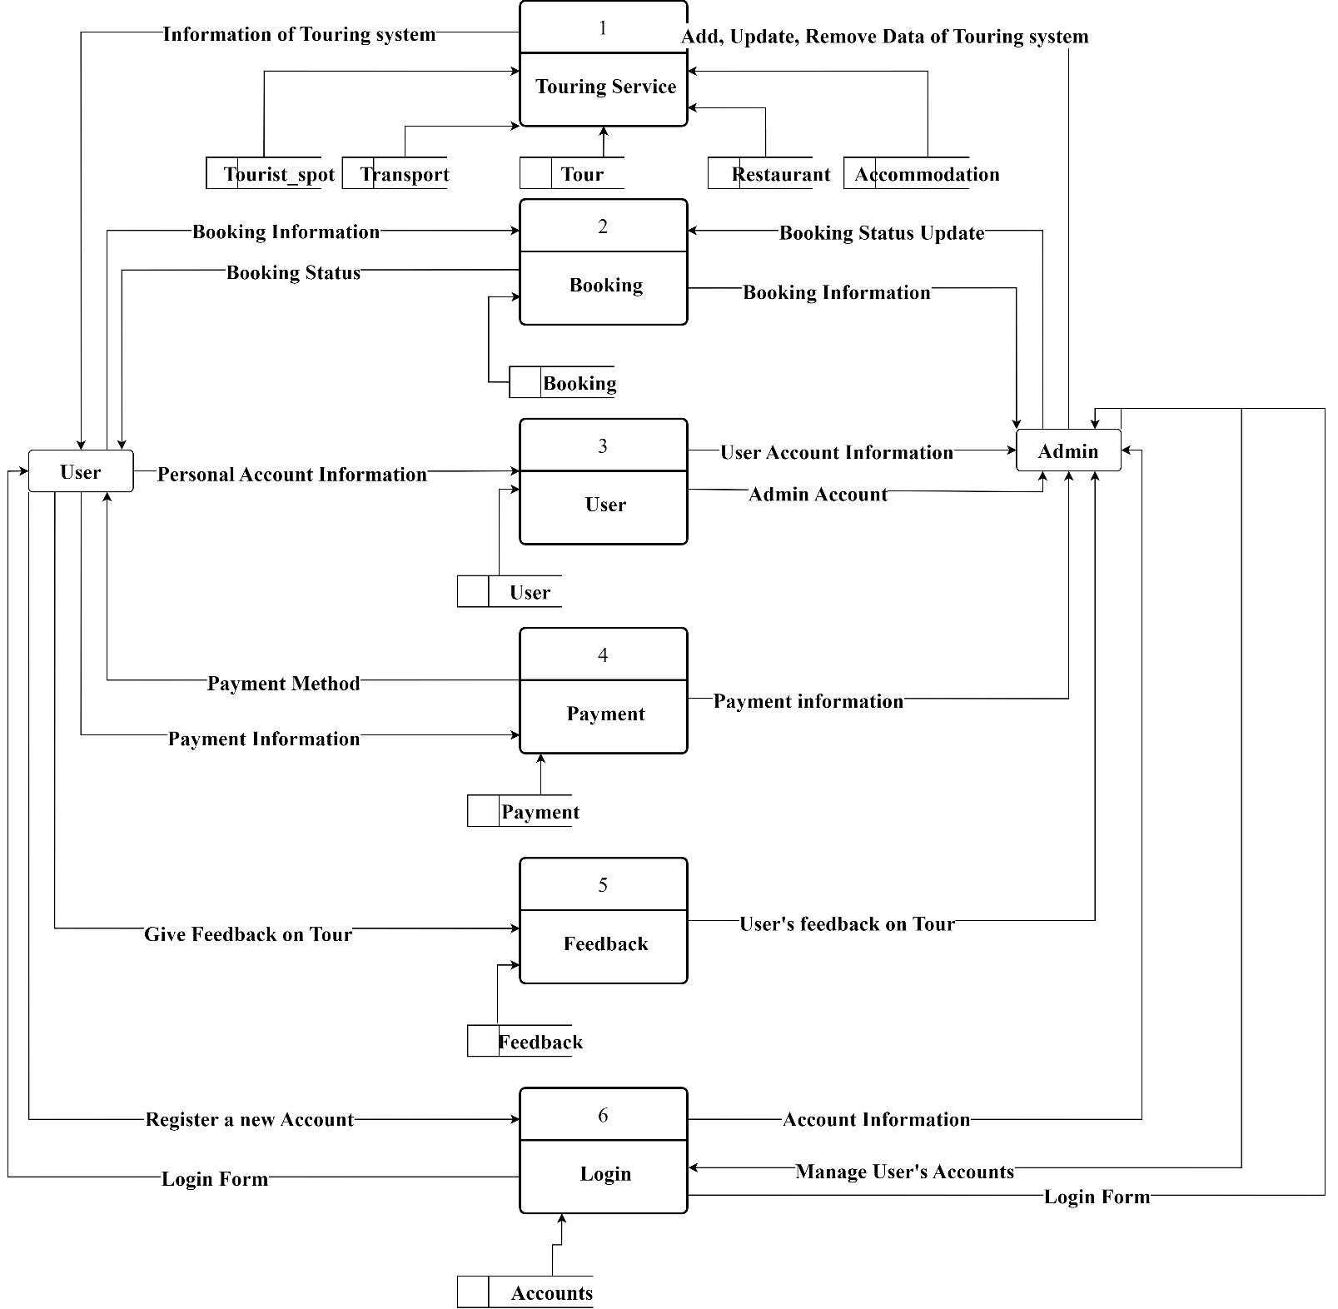

|  |
| --- |
| **A. Entity Relationship Diagram** |

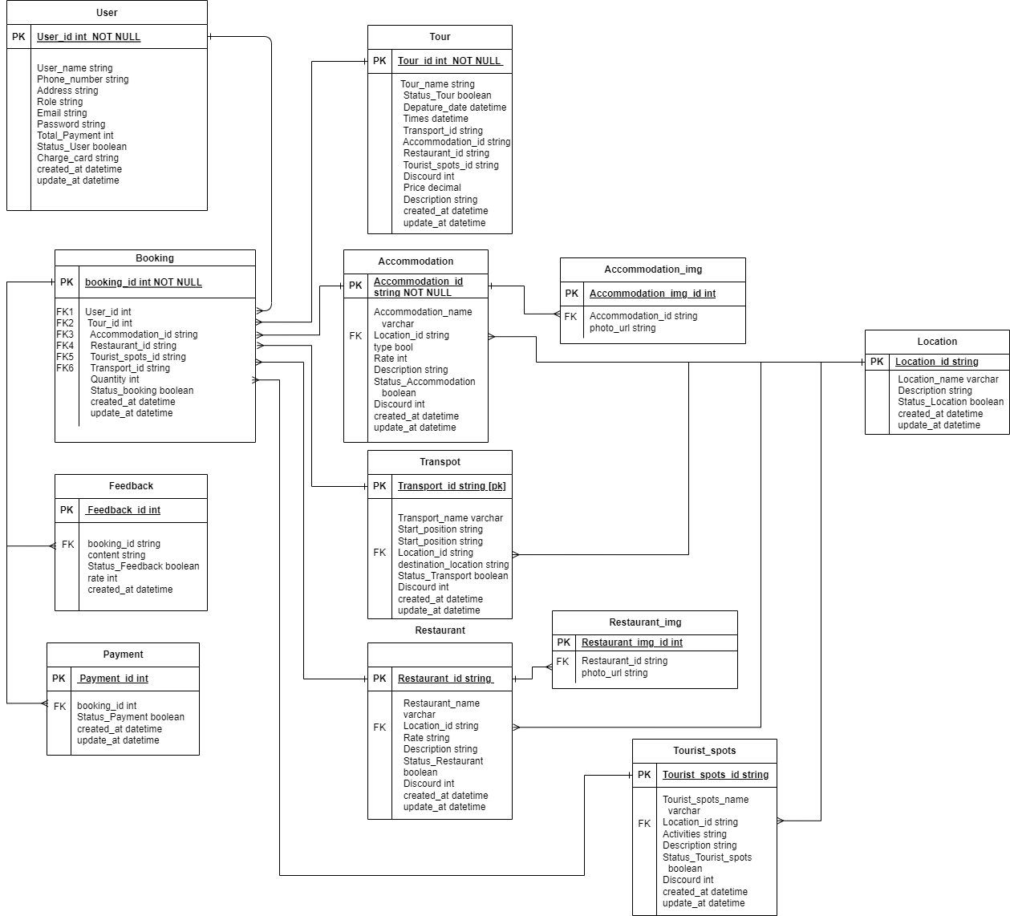

|  |
| --- |
| **B. Entity Attributes** |

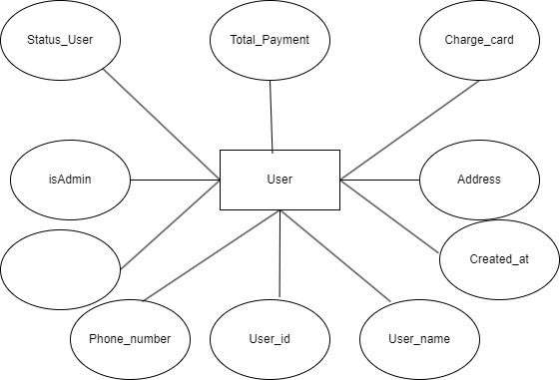

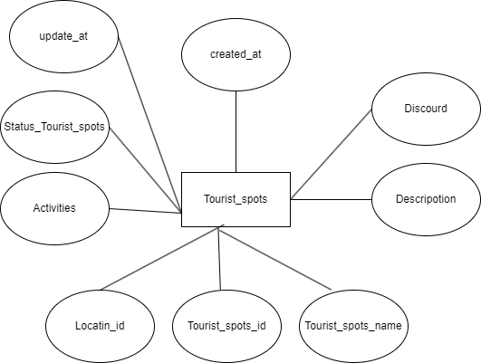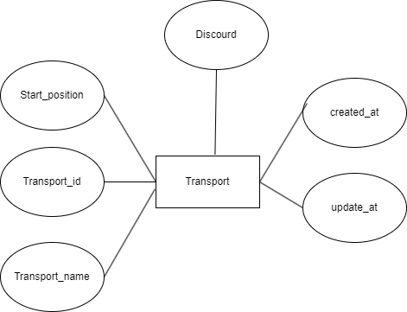

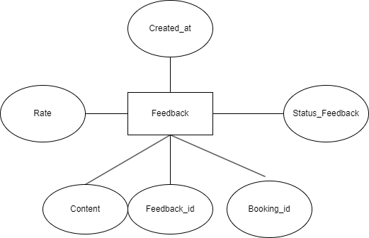

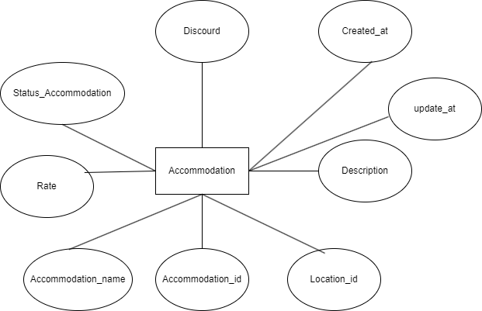

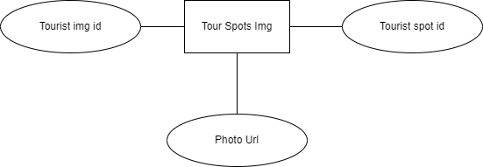

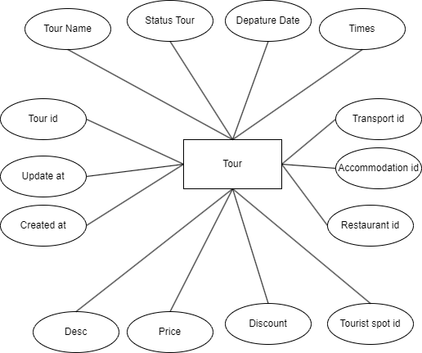

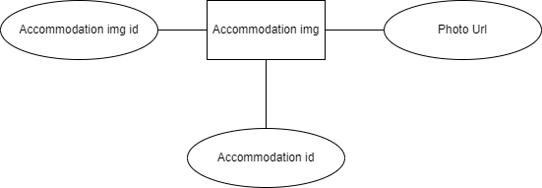

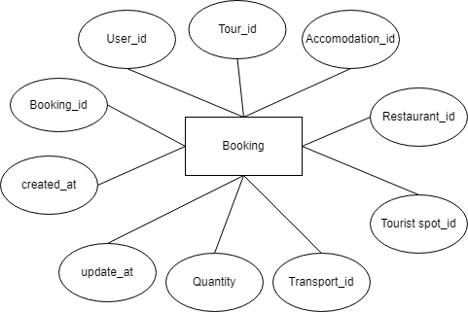

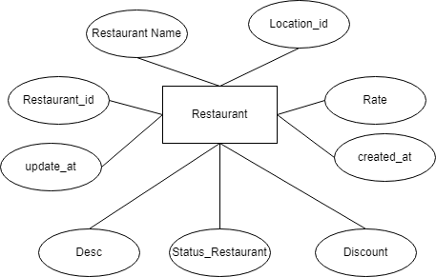

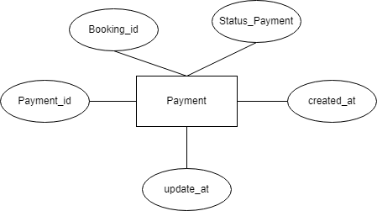

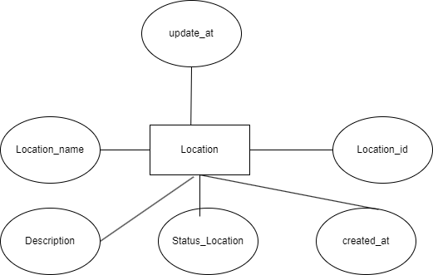

|  |
| --- |
| **Use Case** |

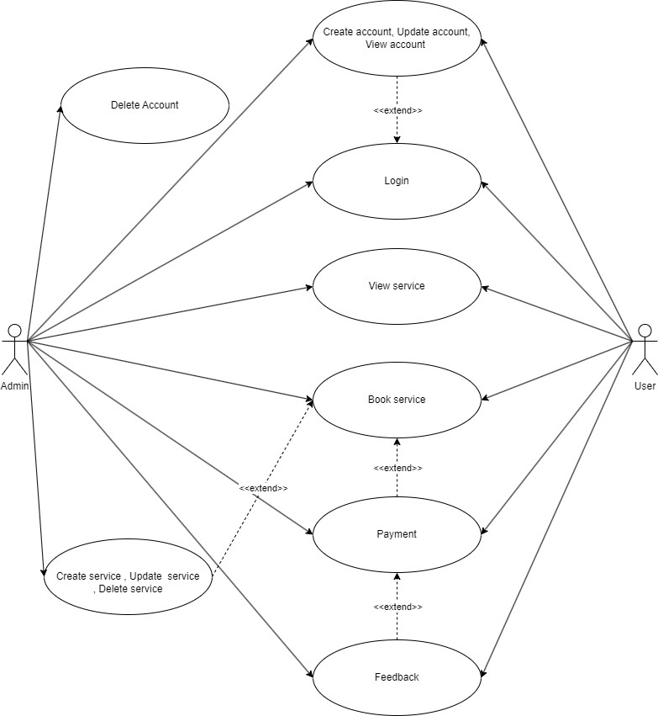

|  |
| --- |
| **SiteMap** |

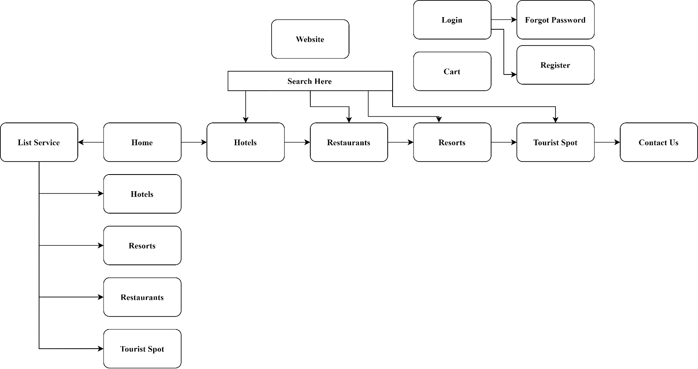

Task Sheet Review 2

|  |  |  |  |  |  |  |  |
| --- | --- | --- | --- | --- | --- | --- | --- |
| **Project Ref. No.:** | | **Project Title:** | **Activity Plan** **Prepared** **By:** | **Date of Preparation of Activity Plan:** | | | |
| **Sr.No.** | **Task** | **Actual Start** **Date** | **Actual** **Days** | **Team** **Mate** **Names** | **Status** |
| 1 | Data Flow Diagram | Karnel Travel | All member | 22/05/2023 | 2 | PHAM GIA HUNG | Completed |
| 2 | Entity Relationship Diagram | 22/05/2023 | 2 | NGUYEN MINH HOANG | Completed |
| 3 | Entity Attributes | 22/05/2023 | 2 | MINH HOANG, NHAT TRUNG,  NGUYEN XUAN THANH | Completed |
| 4 | Use Case |  |  | 22/05/2023 | 2 | DUONG KHAI CUONG | Completed |
| 5 | Site Map |  |  | 22/05/2023 | 1 | PHAM GIA HUNG | Completed |

**Review 03**

|  |
| --- |
| **SCREEN SHOTS** |

# USER

**1.1 Header**

* 1. **List Product**

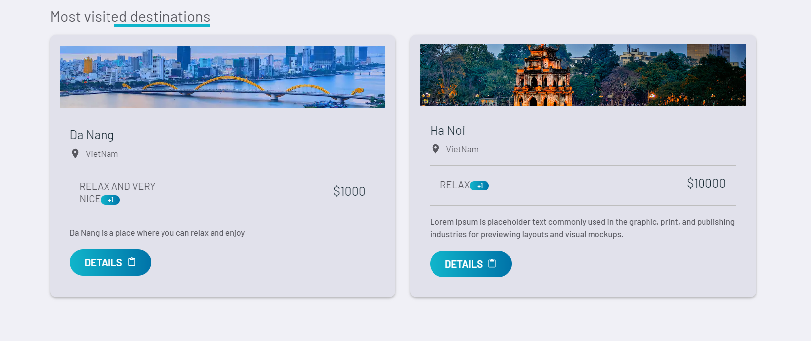

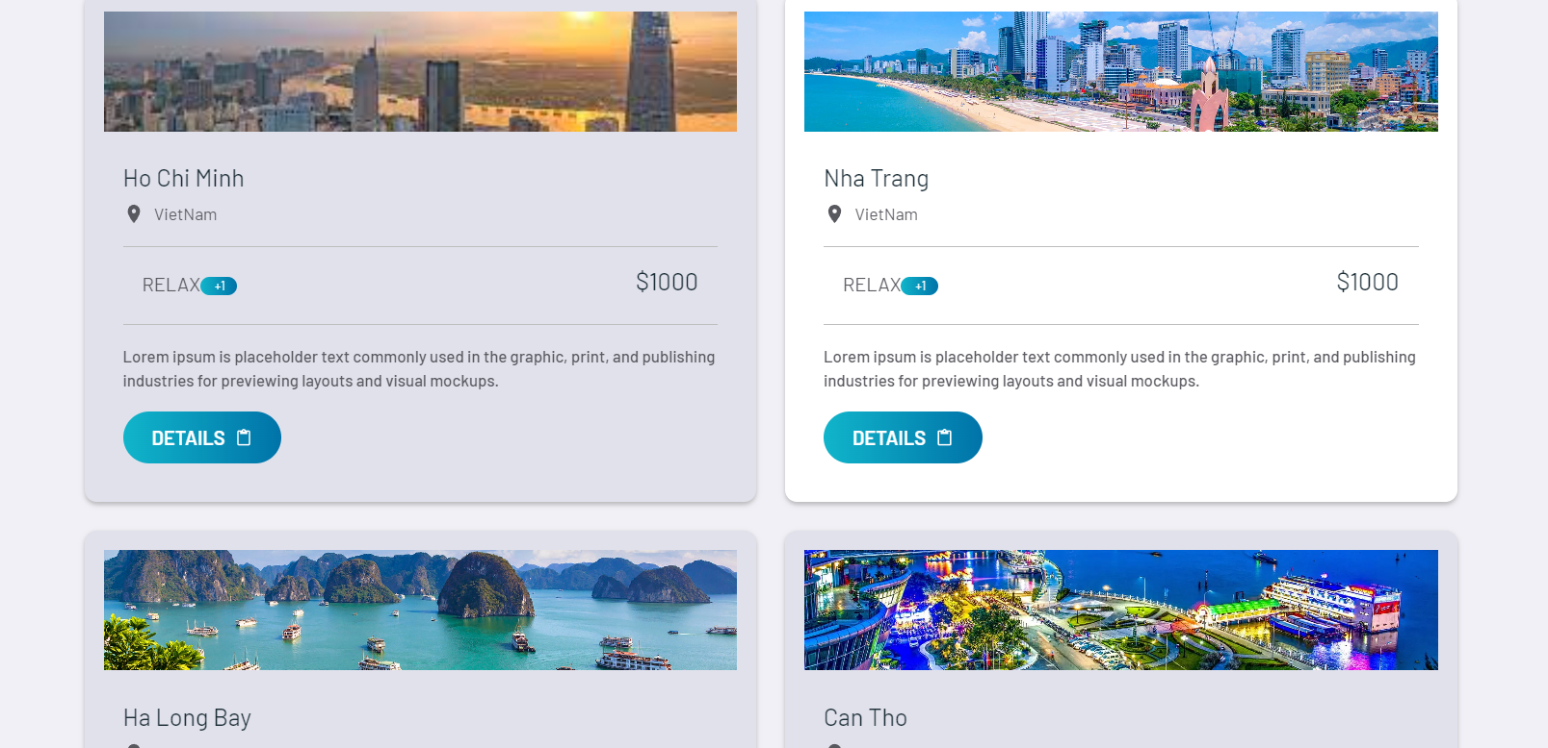

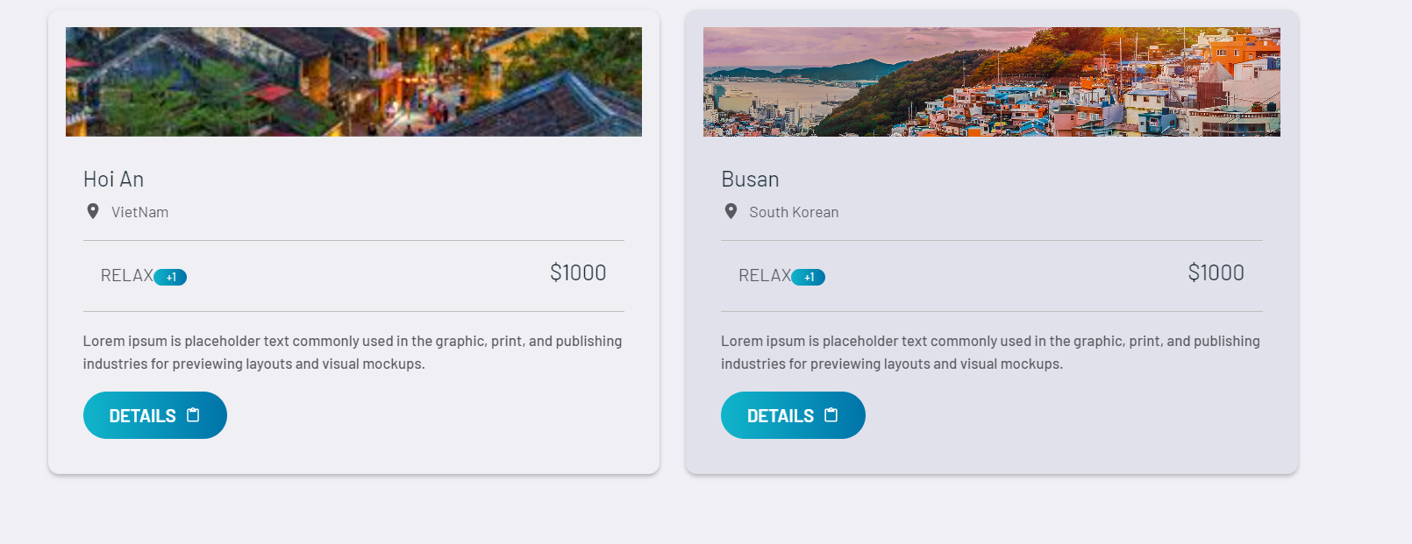

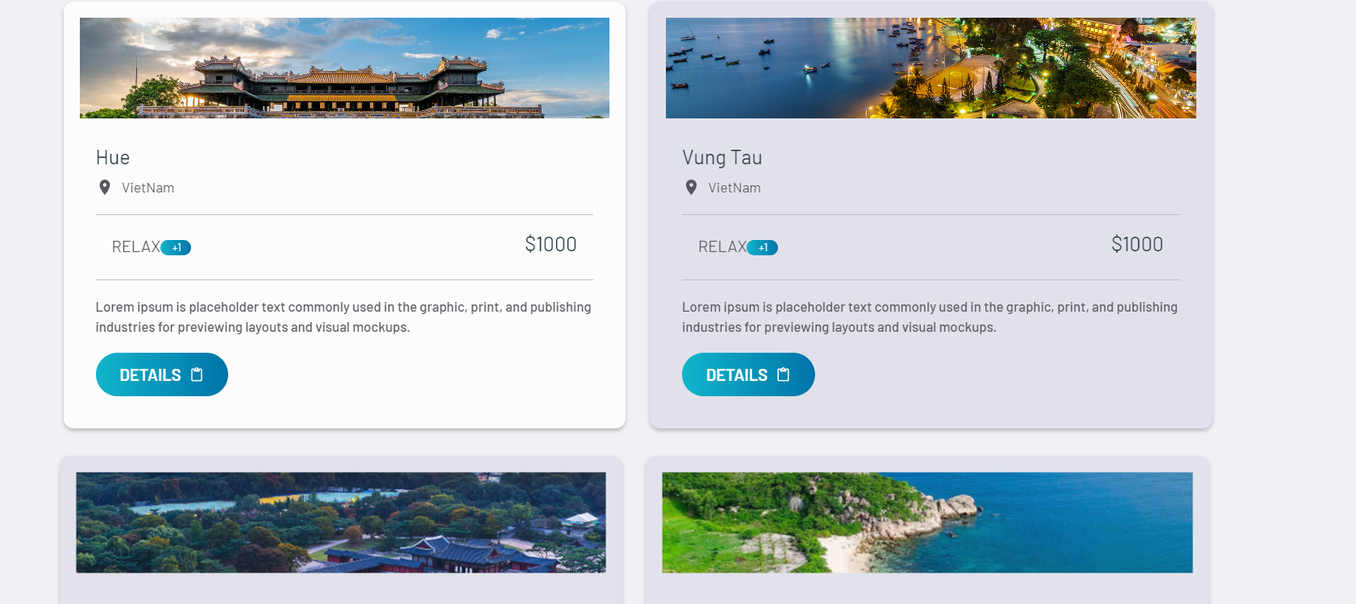

* 1. **Footer**

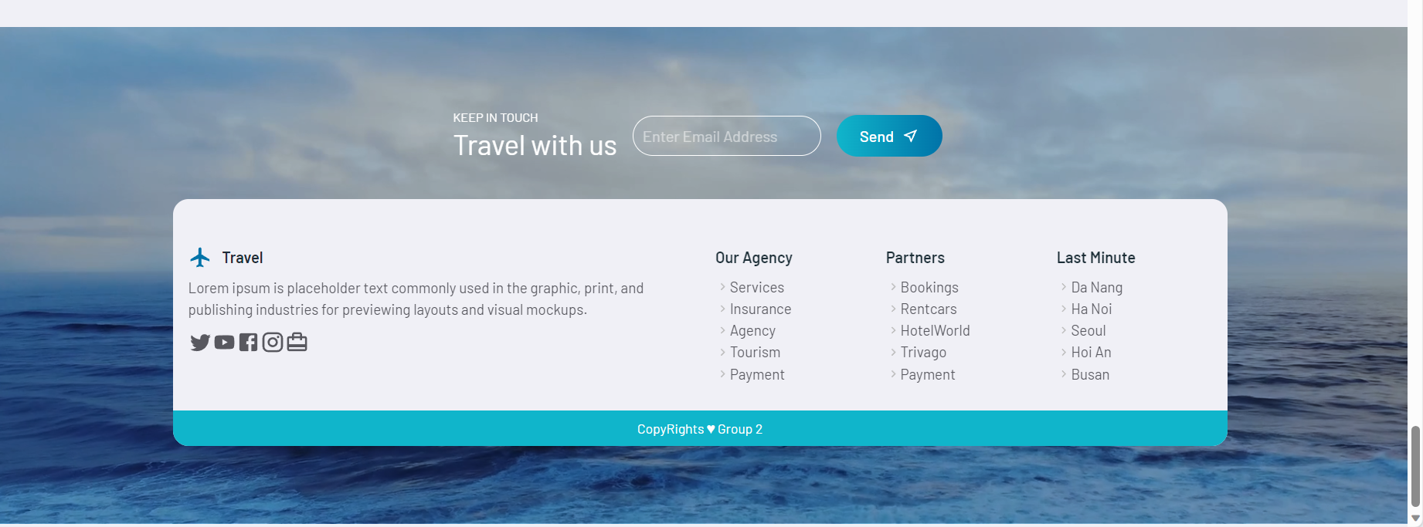

* 1. A screenshot of a computer

     Description automatically generated**FeedBack**
  2. **Transport**

* 1. **Restaurant**

* 1. **Accommodation**

* 1. **Contact Us**

* 1. **Cart**

* 1. **Register**

* 1. **Login**

# ADMIN

## A screenshot of a computer Description automatically generatedAdmin Dashboard

## List Product

## Create form

## Detail Product

# TASK SHEET

|  |  |  |  |  |  |  |  |
| --- | --- | --- | --- | --- | --- | --- | --- |
| **Project Ref. No.:** | | **Project Title:** | **Activity Plan** **Prepared** **By:** | **Date of Preparation of Activity Plan:** | | | |
| **Sr.No.** | **Task** | **Actual Start** **Date** | **Actual** **Days** | **Team** **Mate** **Names** | **Status** |
| 1 | User - Accommodation | Karnel Travel | All member | 25/05/2023 | 23 | PHAM GIA HUNG | Completed |
| Admin - Accommodation | 23 | Completed |
| User - Tour | 23 | Completed |
|  | 23 | Completed |
| 2 | User - HomePage | 25/05/2023 | 23 | HUYNH NHAT TRUNG | Completed |
| User - Restaurant | 23 | Completed |
|  | Admin - Restaurant | 23 | Completed |
|  | Admin – TouristSpot | 25/05/2023 | 23 |  | Completed |
| Admin - Tour | 23 |  | Completed |
| 3 | User - TouristSpot | 23 | DUONG KHAI CUONG | Completed |
|  | User - Cart | 23 |  | Completed |
|  | User - Booking | 23 |  | Completed |
|  | User - Feedback | 23 |  | Completed |
| 4 | Admin - Transport |  |  | 25/05/2023 | 23 | NGUYEN XUAN THANH | Completed |
| Admin - Account | 23 | Completed |
| Admin - Login | 23 | Completed |
| User - Register | 23 | Completed |
|  | User - Login | 23 | Completed |
|  | User - Transport | 23 | Completed |
| 5 | Admin - Location | 25/05/2023 | 23 | NGUYEN MINH HOANG | Completed |
| User - Location | 23 | Completed |